WILLIAM THOMAS HANIGAN
1936 - 2021
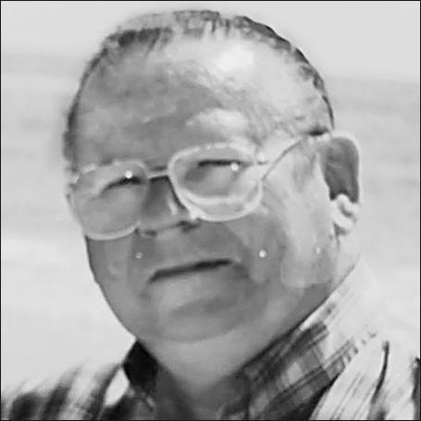
BORN
1936
DIED
2021
FUNERAL HOME
Shepherd Funeral & Cremation Service
216 Main St
Kingston, MA
Share
Send Flowers
HANIGAN, William Thomas Age 85, died peacefully surrounded by his loving family on September 18, 2021. Born on July 3, 1936 he grew up in West Roxbury. After his father passed away when Bill was seven, he and his sister were raised by a single mother and moved to Duxbury. He is survived by his wife Barbara (Hall); his sister Ruth Peck; three children and their partners Bill and Dawn of Boxford, Greg and Beth of Chicago, and Ami and Eric MacFarlane of Pembroke. Bill was also blessed with five grandchildren.
Bill studied at St. John's seminary, left, and pursued his masters in guidance and counseling at Boston College where he met his future wife, Barbara. He also flew ASW operations in the US Navy Reserves for 33 years and taught middle school science in Weymouth.
In 2013, Bill was diagnosed with multiple myeloma and a year later, had a massive stroke; the results of which was right side paralysis and difficulty in talking. Eventually he became weak and took up residence at Newfield House, where he was very well-cared for and loved by the staff until his health issues were so severe that they caused his death.
Visiting Hours will be held on Thursday, September 23rd from 4 to 8 at Shepherd Funeral Home, 216 Main St., KINGSTON. His funeral will be held on Friday, September 24th at 10 at Holy Family Church, 601 Tremont St., Duxbury, followed by Burial at Mayflower Cemetery, Duxbury.
In lieu of flowers, donations may be made to Dana Farber Cancer Institute, 450 Brookline Ave., Boston, MA.

Published by Boston Globe from Sep. 21 to Sep. 22, 2021.

